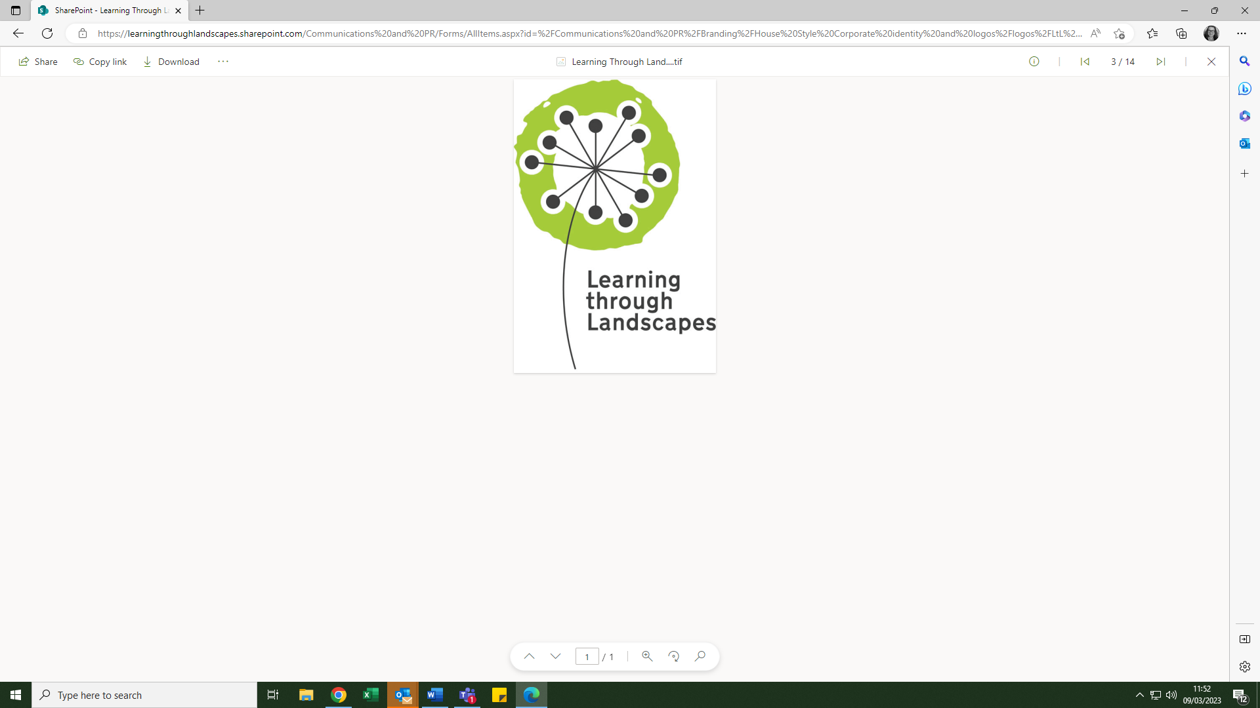

Learning through Landscapes
Local School Nature Grants

Application Summary

Popularity
All rounds of the Local School Nature Grant funding were exceptionally popular, and we received significantly more applications than the grants that could be allocated.

The majority of applications were well considered, and with such a large and strong field we know that schools who put a lot of thought and time into their application may be disappointed.

If you were unsuccessful this time then we encourage you to consider applying in one of the later phases.

Common Themes
In order to help inform any changes you might make to your application please pay close attention the guidance information, particularly across these two themes:-

Pupil involvement – this is really important to the project, and we want to know how the children have been involved in the selecting of products, and their contributions to writing the application. Some people used this space to tell us about the wider eco initiatives or aspirations of the school, which meant they did not have space to tell us much about the involvement of pupils.

Sustainability – a common mistake in relation to this theme was that schools told us about what they had done already, and not how they would keep their outdoor learning area going. Consider who will look after the areas, will you look for other funding sources, will parents be involved, etc.

Response to pupils
We appreciate that many schools will have close involvement form their pupils in the grant application process. Following is a letter responding to your pupils directly which you are welcome to use if you feel it is of help.

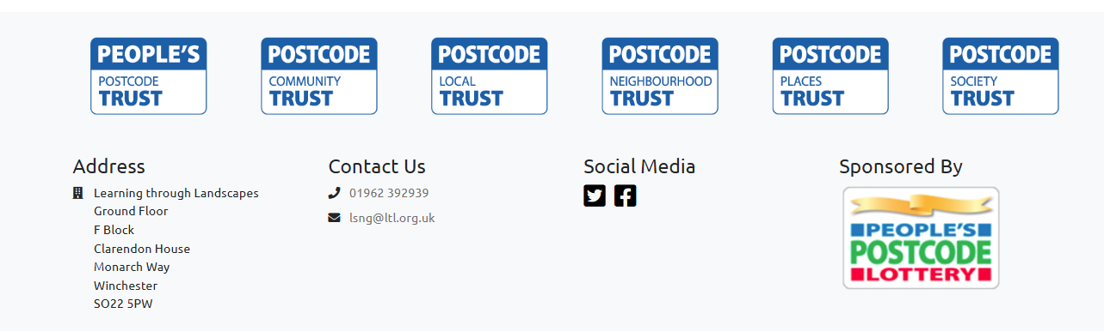

Local School Nature Grants Team
Learning through Landscapes
Clarendon House
Monarch Way
Winchester
SO22 5PW

Dear Pupils

Thank you very much for your Local School Nature Grants application.

We enjoyed hearing about the equipment that would make a difference to your school and how you would like to develop your school grounds. We had a lot of great applications and unfortunately this time your school has not be chosen to receive a grant.

We are sorry that we weren’t able to give you the equipment and training this time, but we hope that you will still enjoy spending time exploring the outdoors.

With best wishes

Kirsty

Kirsty Waterhouse
Project Manger
Local School Nature Grants

